Cook’s Grocery & Delli – Ph: 732-463-1121
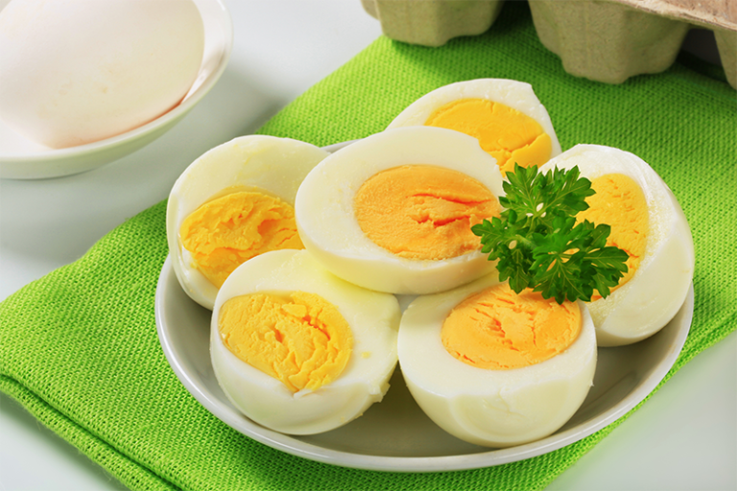
Boil Egge - 2 Egge Price: $2.99

Plain Boil Eggs

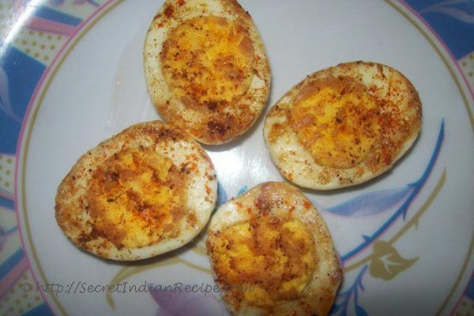
Boil Fried Egge
2 Egge
Price: $3.99

Oil / Butter

Cook’s Grocery & Delli – Ph: 732-463-1121
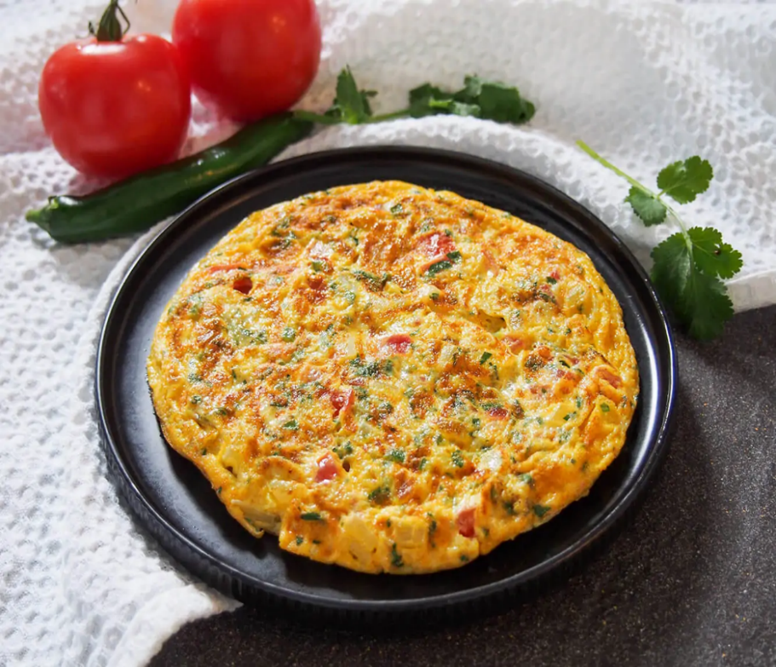
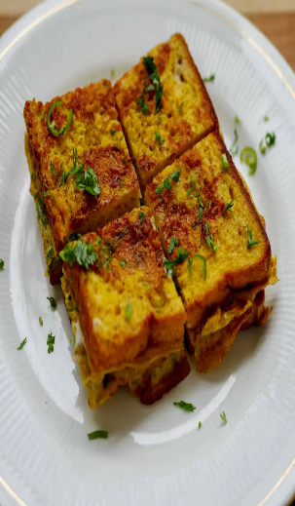

Omelet with Bread / Small bun Singal Egg Price: $ 5.99
Onian, Ginger, Green Chili, Salt, Turmeric, Masala

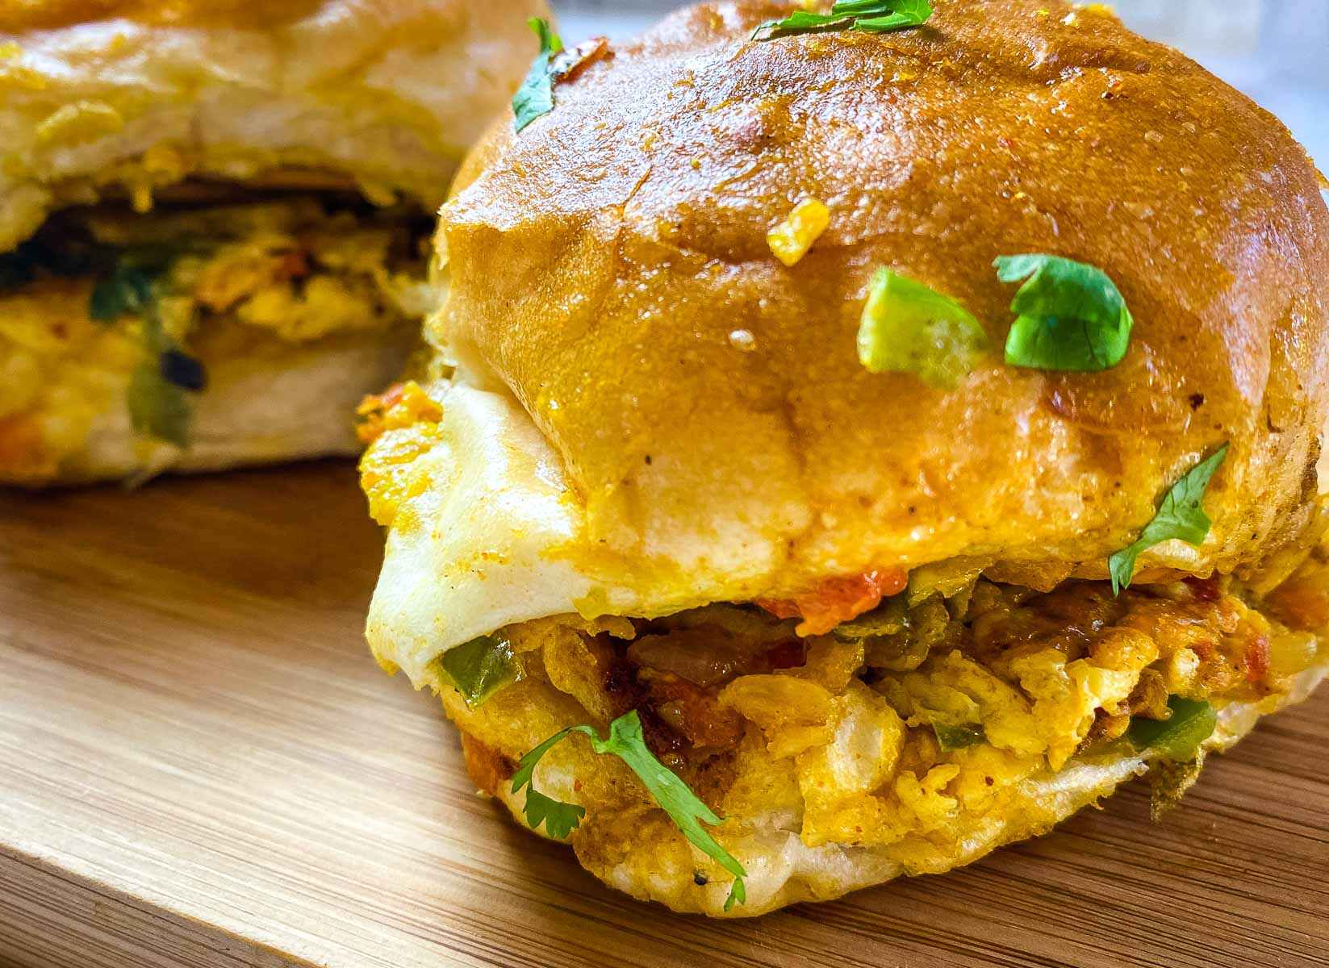
Omelet with Big bun
2 Eggs
Price: $ 9.99

Onian, Ginger, Green Chili, Salt, Turmeric, Spicy Masala
Oil/Butter

Cook’s Grocery & Delli – Ph: 732-463-1121
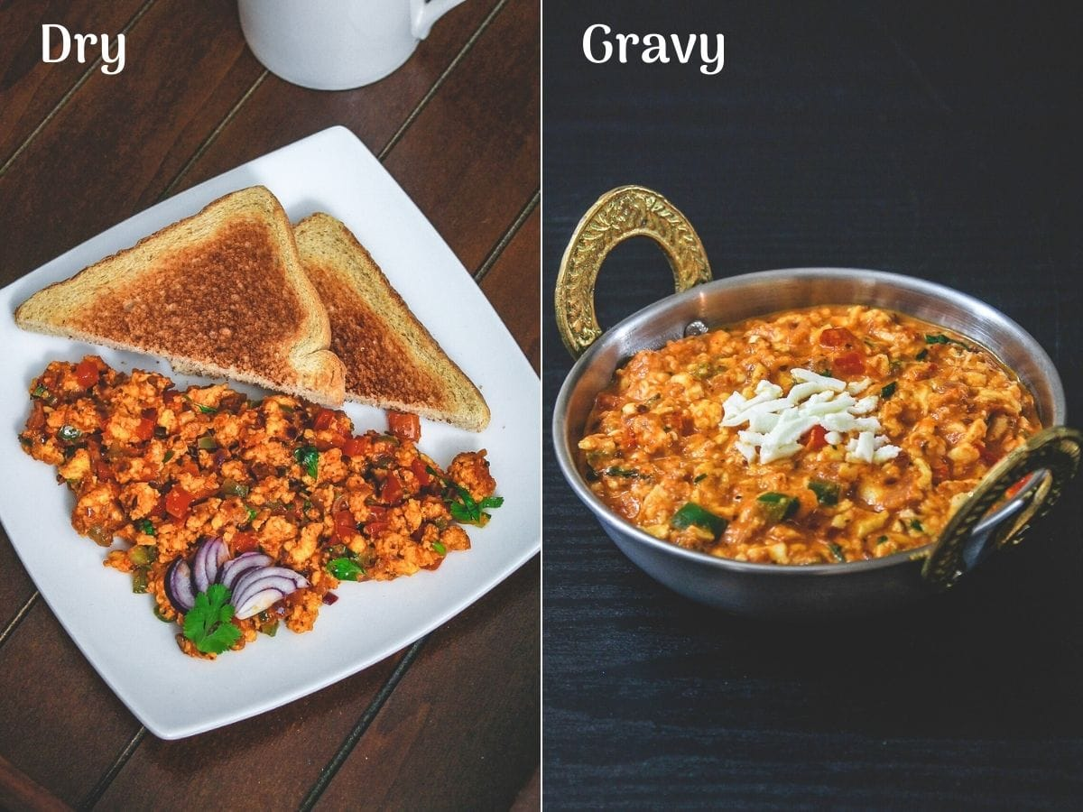

Egg Burji Dry / Egg Burji Gravy 2 Eggs Price: $10.99
Onian, Ginger, Green Chili, Salt, Turmeric, Masala

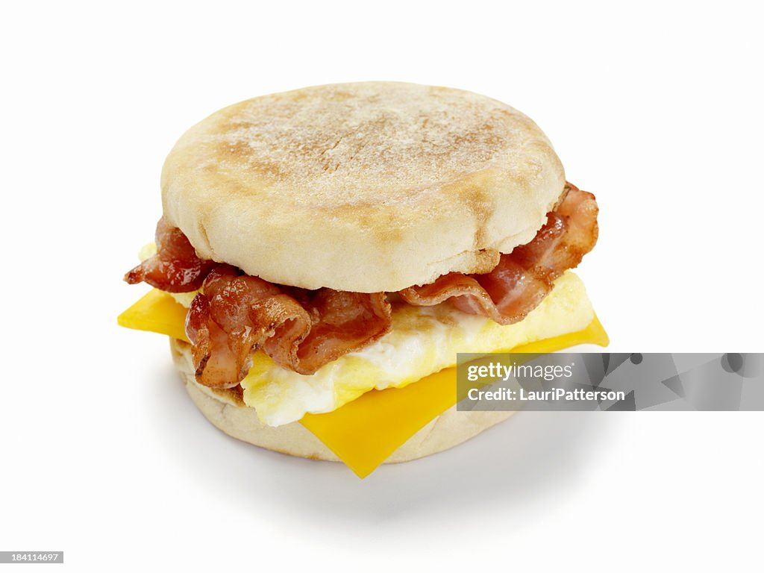
Bacon Egge & Cheese
Jumbo with 2 Ege
Price: $9.99

Small bun with
1 Egge
Price: $7.99

Cook’s Grocery & Delli – Ph: 732-463-1121
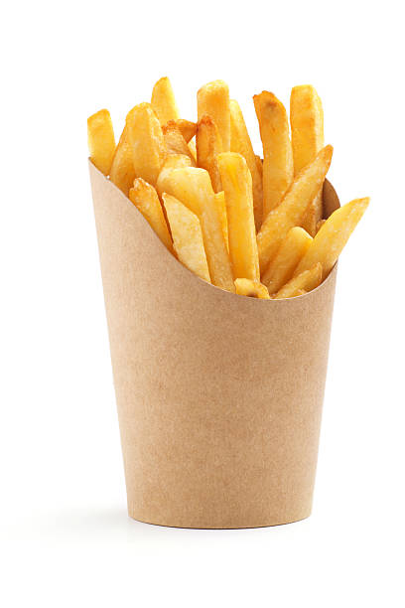
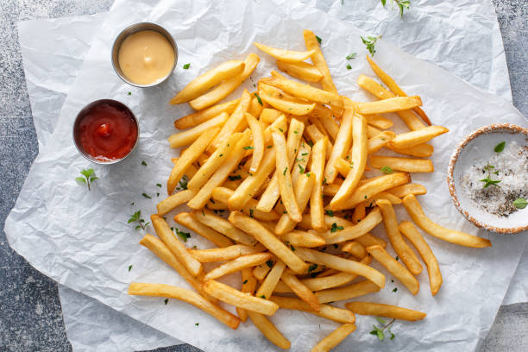
French Fry
Small Size
Price: $2.99

Big Size
Price: 3.49

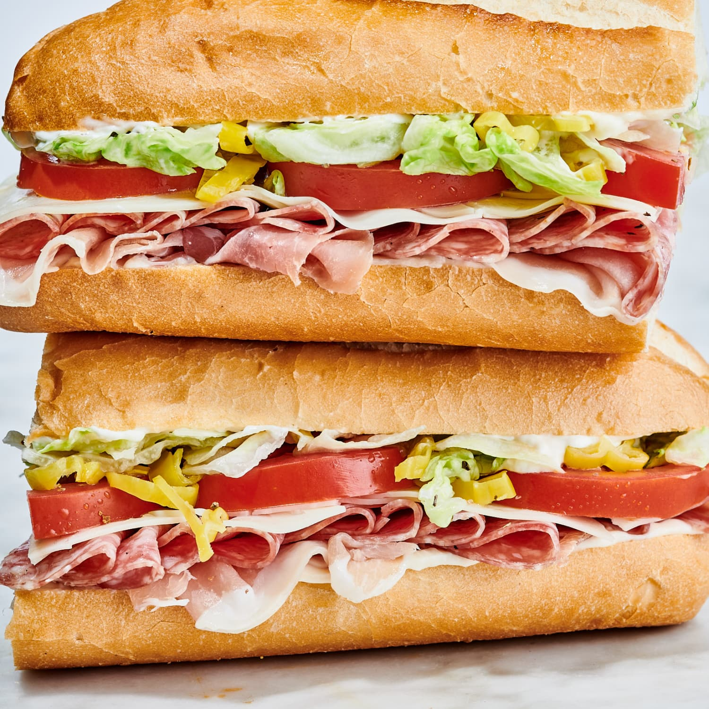
Sandwich
Half
Price: $7.49
Whole
Price: $10.49
Veggies & Cheese
Ham & Cheese
Types of Cheese:
Yello Ame and Swiss
Mayonnaise, Mustard,
Ranch, Hot Peppers,
Pickles, Green Pepper
Cucumber,

Cook’s Grocery & Delli – Ph: 732-463-1121
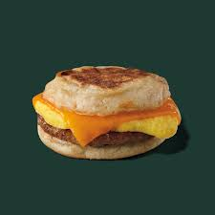
Sausage Egg and cheese
Price: $7.99

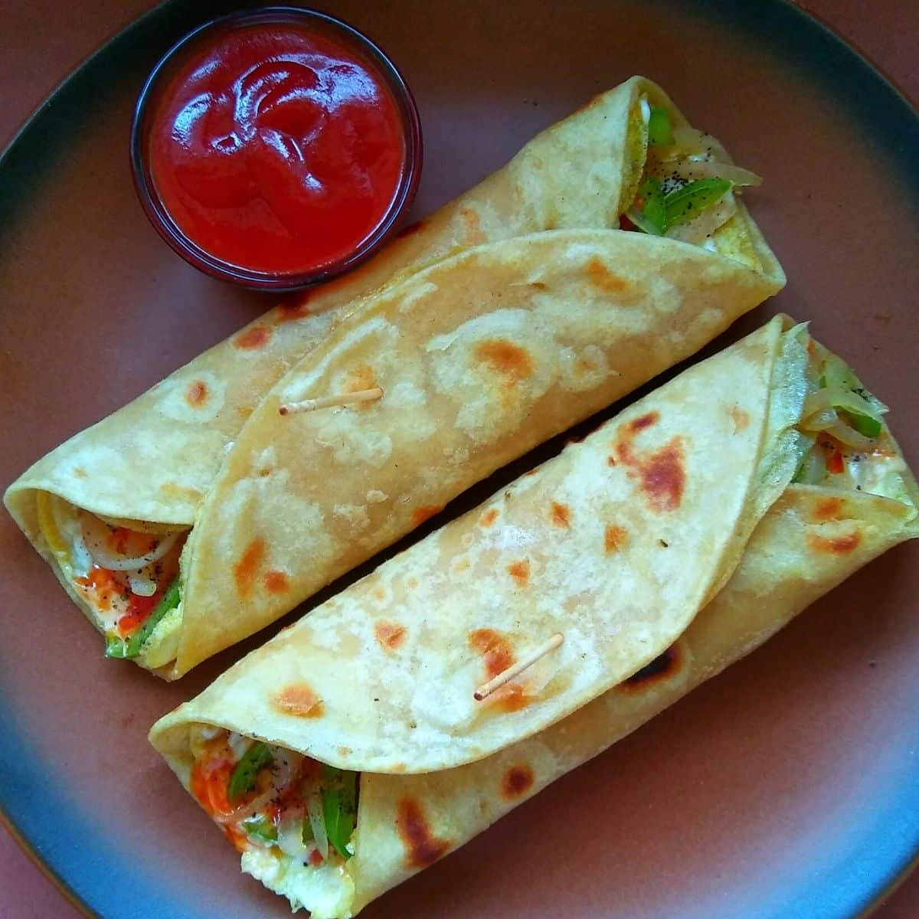

Egg Roll
Price: $8.99

Cook’s Grocery & Delli –Ph: 732-463-1121
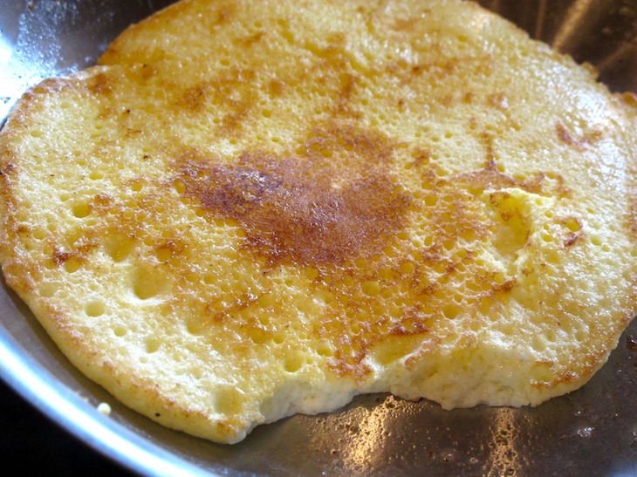
Fluffy Omelets

Price: $6.49

Plain / Regular
Butter / Oil
2 Eggs

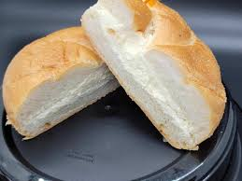
Buttar /Cheam Cheese Roll
Price: $2.49

Tosted / Non Tosted

Cook’s Grocery & Delli – Ph: 732-463-1121

Cook’s Grocery & Delli – Ph: 732-463-1121
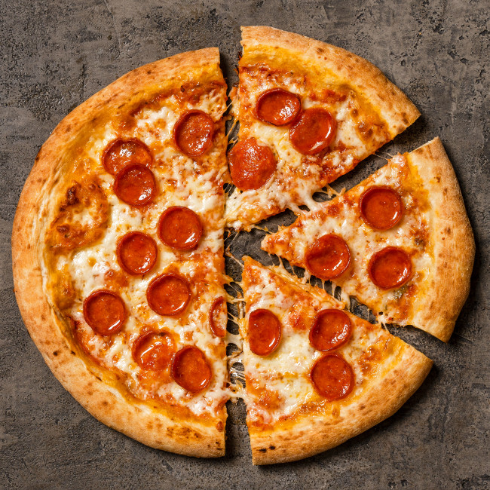
Pepperoni cheese 12 Inch Pizza
Price: $ 9.99

Onion / Green Paper / Jalapeno

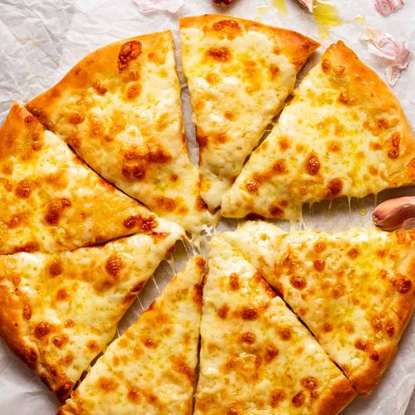
Chess Pizza 12 Inch Pizza
Price: $ 8.99

Onion / Green Paper / Jalapeno

